COMMUNITY PROJECT GRANT GUIDELINES

Lower Eyre Council

Community Project Grant
Application form and guidelines

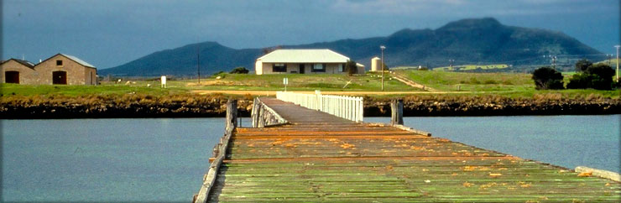 | 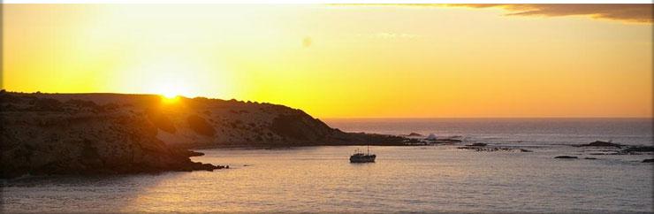
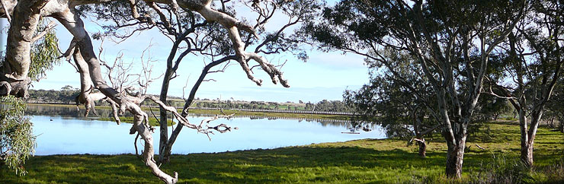 | 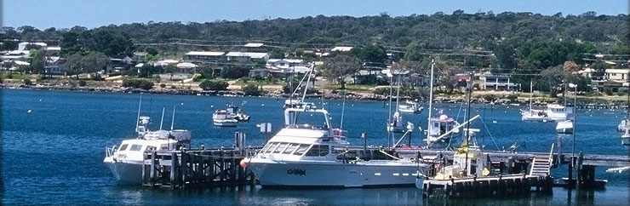
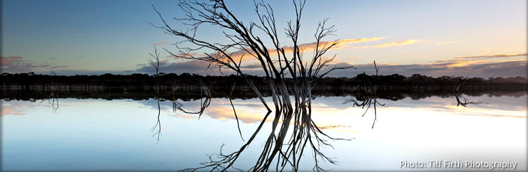
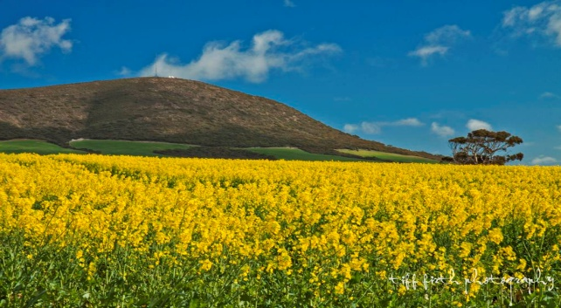

“Working with our Rural & Coastal Communities”

- INTRODUCTION

In recognition of the work contributed to our communities by Community Groups and Clubs, Council provides a budget allocation annually for improvements to community infrastructure by local clubs and bodies.

Please read these guidelines carefully before completing the application form, as applications not meeting the stated funding criteria will be deemed ineligible.

The closing date for applications is 5pm Friday, November 3rd, 2023.

If you require advice to complete the application form, please contact Council on 8676 0400 or email: mail@dclep.sa.gov.au

- ELIGIBILITY

  - Organisations / Clubs must meet the following criteria:
- Be Incorporated.
- Based within the Lower Eyre Council area.
- Must be community based and not for profit.
- Organisations/Clubs must demonstrate:
  - effective management
  - financial sustainability
- Do not have a commercial or political purpose.
  - Projects or community groups in areas which have not received funding in recent years may be prioritised for balance.
  - Each application will be considered on its own merits within the framework of these guidelines and Council policy with no guarantee of approval.

- CONDITIONS

  - APPLICATIONS
    - Applications received after the closing date cannot be accepted.
    - Applications for funding must be on the official application form.
    - All applications must include supporting documentation, including quotes, relevant designs or plans, and evidence of insurance.
    - Applications will only be accepted from community organisations with an established management structure.

  - PROJECTS

    - Grant funding under this program will only be provided for capital projects. Ongoing maintenance works will not be considered.
    - The project must have a clearly stated purpose and a practical plan for achieving that purpose, (including plans or sketches where appropriate).
    - The project should be a response to a clearly demonstrated need and be appropriate to that need.
    - The project should encourage the involvement of volunteers where appropriate.
    - The project is to be completed within twelve months of the date of application.
    - Where grant assistance is provided, the project must not be changed without the written consent of Council.

  - FUNDING
    - The maximum grant for any project is $15,000. Grant requests cannot exceed 50% of total project costs.
    - Council will consider large projects more favourably with preference given where the total project costs exceed $10,000 (GST exclusive) including in-kind contributions.
    - Funding is not recurrent.
    - Where a project or program runs over budget, Council is not responsible in any way for meeting any shortfall.

- GENERAL CONDITIONS
    - Council's assistance must be acknowledged where appropriate.
    - A completed financial acquittal, including an income and expenditure statement and copies of receipts, must be submitted to Council within thirty days of the completion of the project. Organisations which fail to complete this will be ineligible for future funding.
    - If successful with the application, the process from close of round to receipt of financial assistance can take approximately six weeks.
    - Organisations need to provide evidence (Certificate of Currency) to demonstrate they are insured.
    - The repair or replacement of facilities damaged by explosion, vandalism, flood, storm, fire, or other natural disaster that would normally be covered by insurance are ineligible unless there is a demonstrated improvement to facilities beyond what was previously available.
COMMUNITY PROJECT GRANT APPLICATION FORM

Please Note:

- Applicants are advised to read the guidelines prior to completion of this form as those not meeting the guidelines will be deemed ineligible.
- All documentation, where requested, must be submitted.
- Completed applications with all supporting documentation should be forwarded to:

Lower Eyre Council
Mail: PO Box 41, Cummins SA 5631
Email: mail@dclep.sa.gov.au

PART A – APPLICANT DETAILS

Name of group/organisation:
Number of members: |  | Female: |  |  |  | Male:
 |  | Junior: |  |  |  | Senior:
 |  | Members with disability:
Is your organisation incorporated? |  | Yes No
Does your organisation have an ABN? |  | Yes No ABN: _____________________
Is your organisation registered for GST? |  | Yes No
Is your organisation insured?  (Please attach evidence such as a Certificate of Currency)  Postal address: |  | Yes No
Contact person:
Position in organisation:
Email Address:
Phone no. (Daytime): |  |  | (AH):

PART B – PROJECT DETAILS
(Please attach extra pages if insufficient space is provided.)

Project title:

Project location:

Start date: |  | Completion date:

Please provide a description of your project and how it will be achieved:

Who will benefit from this project?

How was the need for this project determined?

If you are seeking a contribution from Council of $1,000 or more, please state how this support will be acknowledged?

Please detail how the project will be maintained or managed after completion:

PART C – FUNDING SOURCES

Has your organisation received funding from the Lower Eyre Council or other funding sources in the past three years?

Purpose and funding source | Amount | Year

PART D – PROJECT BUDGET

Total Project Cost: $

Council Grant Request: $ Note: Maximum grant is $15,000 and can more no more than 50% of total project cost

Please provide a detailed budget for your project. Please note total income must match total project costs. Provide quotes to demonstrate the costs, and any relevant building or concept plans for the project. Attach additional pages if there is insufficient space provided.

PROJECT COSTS
Project item/description | Cost $
Total | $

PROJECT INCOME
Project Income – Cash contributions | Income $
Applicant’s cash contribution
Other confirmed funding sources
Project Income – In-kind contributions (Estimated at $25/hr)
Council grant request | $
Total | $
Note total project costs must match total project income

Could this project be undertaken if grant offered was less than the amount applied for? | Yes No
Could project be undertaken if funding was split over consecutive financial years? | Yes No

PART E – ACCEPTANCE OF COMMUNITY GRANT CONDITIONS

Please read the following conditions and complete the checklist. Incomplete applications will be ineligible for funding.
- The Lower Eyre Council’s support of the project will be acknowledged in any media coverage or promotional activities.
- The grant must be spent on the agreed project only.
- Unspent funds will be returned to Council.
- A copy of the organisation’s most recent income/expenditure statement is attached.
- Quotes for project costs are attached.
- Any relevant plans for this project are attached.
- Evidence of insurance (ie Certificate of Currency) is attached.

DECLARATION

Our Organisation agrees to comply with the conditions of the grant.

I declare that I have been authorised to prepare and submit this application and that the information presented on this form is correct. I understand that if Council approves the application, we will abide by the conditions as listed in the guidelines and application form.

Print Name:

Organisation:

Position:

Email:

Signature:

Date:

