COMMUNITY HALLS SUPPORT PROGRAM GUIDELINES

Lower Eyre Council

Community Halls Support Program
Application form and guidelines

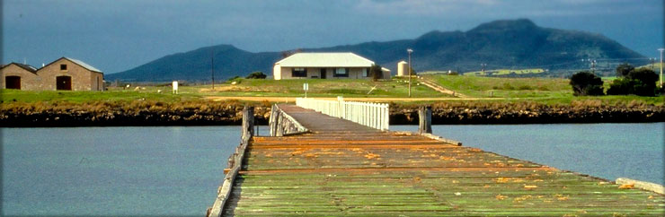
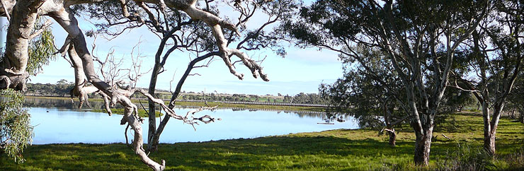 | 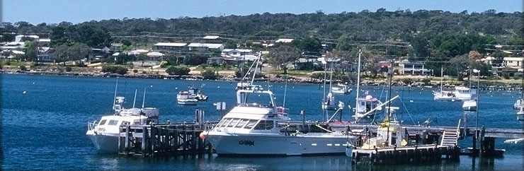
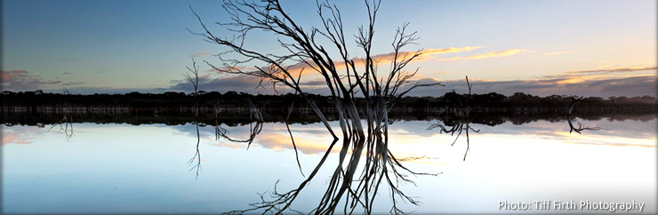

“Working with our Rural & Coastal Communities”
https://www.lowereyrepeninsula.sa.gov.au/

- INTRODUCTION

In recognition of the value and historical significant of local halls, Council provides a budget allocation annually for improvements to community halls by local incorporated clubs, progress associations, or community-based groups.

Please read these guidelines carefully before completing the application form, as applications not meeting the stated funding criteria will be deemed ineligible.

The closing date for applications is 5pm Friday, 3rd November, 2023.

If you require advice on completing the application form, please contact Council on 8676 0400 or email: mail@dclep.sa.gov.au

- ELIGIBILITY

  - Halls must meet the following criteria:
- Based within the Lower Council area.
- Must be community based and not for profit.
- Must demonstrate:
  - Regular use and effective management
- Do not have a commercial or political purpose.
  - The applying body (Applicant) must be incorporated.
  - Halls with associated active sporting bodies must demonstrate that the application is for the benefit of the hall and not for members of the associated sporting body.
  - An organisation will only be eligible for funding once in any one financial year and in no more than two consecutive financial years.
  - Each application will be considered on its own merits within the framework of these guidelines and Council policy with no guarantee of approval.

- CONDITIONS

  - APPLICATIONS
    - Applications received after the closing date may not be accepted.
    - Applications for funding must be on the official application form.
    - All applications must include supporting documentation, including quotes, relevant designs or plans, and evidence of insurance.
    - Applications will only be accepted from community organisations with an established management structure.

  - PROJECTS

    - The project must have a clearly stated purpose and a practical plan for achieving that purpose, (including plans or sketches where appropriate).
    - The project should be a response to a clearly demonstrated need and be appropriate to that need.
    - The project should encourage the involvement of volunteers where appropriate.
    - The project is to be completed within twelve months of the date of application.
    - Where grant assistance is provided, the project must not be changed without the written consent of Council.

  - FUNDING
    - The total pool for funding for this program is $5,000. Grant requests cannot exceed 75% of total project costs. Unallocated funds will be allocated to a Community Halls Reserve for applications in future years.
    - Funding is not recurrent.
    - Where a project or program runs over budget, Council is not responsible in any way for meeting any shortfall.

- GENERAL CONDITIONS
    - Council's assistance must be acknowledged where appropriate.
    - A completed financial acquittal, including an income and expenditure statement and copies of receipts, must be submitted to Council within thirty days of the completion of the project. Organisations which fail to complete this will be ineligible for future funding.
    - If successful with the application, the process from close of round to receipt of financial assistance can take approximately six weeks.
    - Organisations need to provide evidence (Certificate of Currency) to demonstrate they are insured.
    - The repair or replacement of facilities damaged by explosion, vandalism, flood, storm, fire, or other natural disaster that would normally be covered by insurance are ineligible unless there is a demonstrated improvement to facilities beyond what was previously available.

COMMUNITY HALLS SUPPORT PROGRAM APPLICATION FORM

Please Note:

- Applicants are advised to read the guidelines prior to completion of this form as those not meeting the guidelines will be deemed ineligible.
- All documentation, where requested, must be submitted.
- Completed applications with all supporting documentation should be forwarded to:

Lower Eyre Council
Mail: PO Box 41, Cummins SA 5631
Email: mail@dclep.sa.gov.au

PART A – APPLICANT DETAILS

Name of group/organisation:
Is your organisation incorporated? |  | Yes No
Does your organisation have an ABN? |  | Yes No ABN: _____________________
Is your organisation registered for GST? |  | Yes No
Is your organisation insured?  (Please attach evidence such as a Certificate of Currency)  Postal address: |  | Yes No
Contact person:
Position in organisation:
Email Address:
Phone no. (Daytime): |  |  | (AH):

PART B – PROJECT DETAILS
(Please attach extra pages if insufficient space is provided.)

Project title:

Project location:

Start date: |  | Completion date:

Please provide a description of your project:

How often is the hall used? Include details of which groups or people use the hall, regularity of use, and any potential new users that could be attracted.

How is the hall managed or governed?

If you are seeking a contribution from Council of $1,000 or more, please state how this support will be acknowledged?

Please detail how the project will be maintained or managed after completion:

PART C – FUNDING SOURCES

Has your organisation (including sub-committees and associated committees) received funding from the Lower Eyre Council or other funding sources in the past three years?

Purpose and funding source | Amount | Year

PART D – PROJECT BUDGET

Total Project Cost: $

Council Grant Request: $ Note: Maximum grant is 75% of total project cost

Please provide a detailed budget for your project. Please note total income must match total project costs. Provide quotes to demonstrate the costs, and relevant building or concept plans for the project. Attach additional pages if there is insufficient space provided.

PROJECT COSTS
Project item/description | Cost $
Total | $

PROJECT INCOME
Project Income – Cash contributions | Income $
Applicant’s cash contribution
Other confirmed funding sources
Project Income – In-kind contributions (Estimated at $25/hr)
Council grant request | $
Total | $
Note total project costs must match total project income

Could this project be undertaken if grant offered was less than the amount applied for? | Yes No
Could project be undertaken if funding was split over consecutive financial years? | Yes No

PART E – ACCEPTANCE OF COMMUNITY GRANT CONDITIONS

Please read the following conditions and complete the checklist. Incomplete applications will be ineligible for funding.
- The Lower Eyre Council’s support of the project will be acknowledged in any media coverage or promotional activities.
- The grant must be spent on the agreed project only.
- Unspent funds will be returned to Council.
- A copy of the organisation’s most recent income/expenditure statement is attached.
- Quotes for project costs are attached.
- Any relevant plans for this project are attached.
- Evidence of insurance (ie Certificate of Currency) is attached.

DECLARATION

Our Organisation agrees to comply with the conditions of the grant.

I declare that I have been authorised to prepare and submit this application and that the information presented on this form is correct. I understand that if Council approves the application, we will abide by the conditions as listed in the guidelines and application form.

Print Name:

Organisation:

Position:

Email:

Signature:

Date:

